Product Requirements Document (PRD)
MMR Flow Optimisation — Insurance Replacement Conversion

Table of Contents
Table of Contents 1
1. Context & Background 2
2. Business Objectives 2
3. Problem Statement 2
4. Intended Behaviour 3
5. Current User Experience & Flows (As-Is) 4
6. Target User Experience & Flows (To-Be) 5
7. MMR Booking Time Rules & Constraints 6
8. Functional Requirements 7
9. Non-Functional Requirements 8
10. Success Metrics & Tracking Plan 8
11. Out of Scope 8

The requirements outlined in this PRD have been formulated based on inputs gathered during multiple discovery and alignment sessions with key business stakeholders, including:
- Randy – XXX
- Anupam – XXX
- Zac Cadi – Director Strategic Technology Initiatives
- Kalyan Chintam– VP Product Engineering
- Vikram Rajagopalan – VP Innovation and AI
- Nicholas Cappellucci – Snr Director Replacement Sales
- Gimhana Dissanayake – Division VP HLE and HLE Sales

1. Context & Background
When a lead comes through Hertz's insurance partners, the lead automatically receives an SMS with a link to the Manage My Reservation (MMR) web application. The MMR allows customers to review their pre-populated reservation details and confirm their rental booking through a guided two-page flow.
Customers who complete the MMR flow have a significantly higher conversion rate than those who do not. Therefore, increasing MMR engagement and completion directly lifts overall insurance replacement conversion.
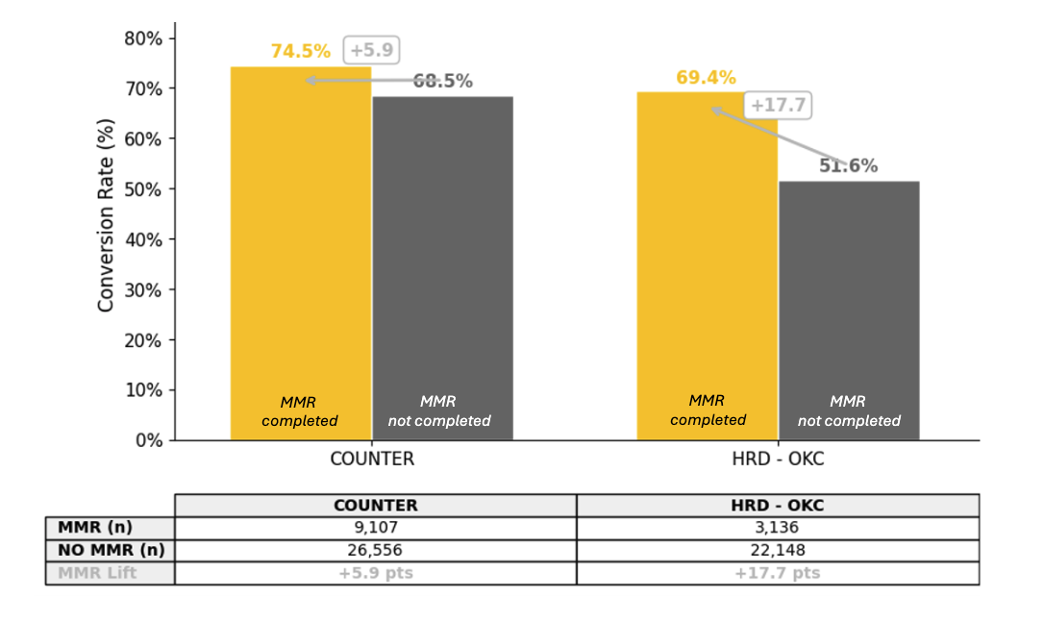
The current MMR funnel performance is as follows:
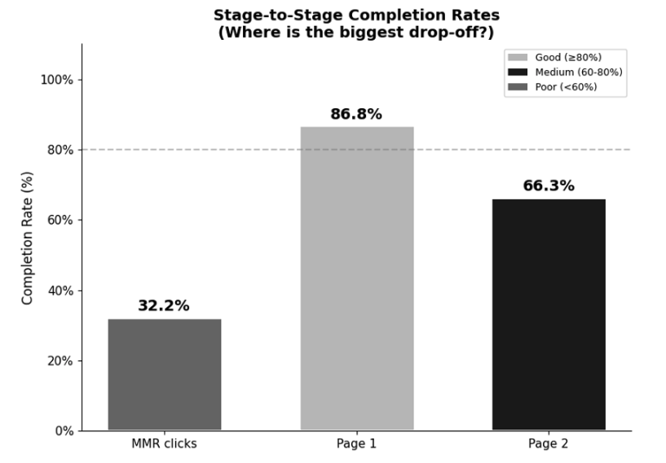
The 34% drop-off on Page 2 represents a significant loss of engaged customers who have already demonstrated intent by clicking the link and completing Page 1. This PRD defines the changes required to reduce Page 2 abandonment and increase SMS click-through, thereby lifting overall conversion.

2. Business Objectives
- Increase MMR SMS click-through rate from 32% toward 40–50%
- Increase MMR Page 2 completion rate from 66% toward 82–89%
- Reduce form abandonment by accommodating all customer scenarios, not just the body-shop-ready happy path
- Capture same-day rental demand (37% of leads) that is currently blocked by booking guardrails
- Secure early customer commitment to Hertz to reduce competitor flipping at the body shop
These objectives directly support:
- Incremental conversion uplift of +1.24 to +2.29 percentage points (MMR Page 1 + Page 2 combined)
- Estimated $1.2M–$2.3M EBITDA uplift
- Estimated $3.3M–$6.2M Revenue uplift
- Based on $1M EBITDA and $2.7M Revenue per 1% conversion improvement

3. Problem Statement
Low SMS Click-Through
Only 32% of customers who receive the MMR SMS click the link. There is currently no follow-up or reminder mechanism for non-clickers.
Page 2 Drop-Off
87% of customers who click the MMR link complete Page 1, but only 66% complete Page 2 — a 34% drop-off rate. Page 2 has friction including confusing fields and an inflexible flow that only supports one customer journey.
MMR only supports customers who already have a body shop reservation.
Customers who fall outside this single happy path cannot complete the MMR flow:
- Do not have a body shop reservation yet
- Do not know who their body shop will be
- Need to pick up today (same-day)
- Want to be picked up from somewhere other than the body shop (e.g., home, work, other location)
- Do not need pickup at all
Same-Day Demand Is Blocked
From a sample of 700 outbound HRD calls, 37% of all leads needed same-day rentals. However, the MMR booking time guardrails prevent these customers from completing the flow. The system enforces a 2-hour buffer from the current time (rounded to 30-minute increments), plus a 1-hour buffer before the location's closing time. For a branch closing at 4:30pm, customers on the page after approximately 1:30pm see no available time slots. For a 4:00pm close, the effective cutoff is approximately 1:00pm.
These customers — who are often the most urgent and motivated — see no options, perceive that Hertz cannot help them, and drop out of the flow entirely.
Unnecessary Confirmation Step
After completing Page 2, customers are shown a confirmation pop-up modal that was originally introduced for a credit card deposit flow. Credit cards are no longer collected, making this extra step unnecessary friction.

4. Intended Behaviour
The MMR flow should accommodate all insurance replacement customer scenarios — not just those with an existing body shop reservation. Specifically:
- Customers with or without a body shop reservation can complete the MMR flow
- Customers who need same-day pickup are not blocked — they receive a soft confirmation and are routed to HRD for immediate assistance
- Pickup location is not limited to body shop — customers can select home, work, or other locations
- The flow completes in all scenarios, ensuring every engaged customer gets a commitment touchpoint with Hertz
- Non-clickers receive a reminder SMS to re-engage them into the funnel

5. Current User Experience & Flows (As-Is)
The MMR flow currently consists of three steps shown in a progress bar: (1) My Details and Damaged Vehicle, (2) Start a Reservation, and (3) Confirmation.
Page 1 — My Details and Damaged Vehicle
- Customer enters via SMS link with confirmation number and last name
- Page displays: phone number, email, insurance company name, vehicle make, model, year, and a "Was your vehicle stolen?" checkbox
- Fields are pre-populated from HLES where available; otherwise the customer must enter them
- All vehicle fields are required (no "unknown" option)
- 87% of customers who reach this page complete it
Page 2 — Start a Reservation
- "Do you need a Hertz rep to pick you up from the body shop?" — Yes / No radio buttons
- Hertz Rental Location (dropdown, pre-populated)
- Pickup Date (date picker, defaults to next day)
- Pickup Time (dropdown, 30-minute increments with guardrails)
- Body Shop Location (dropdown with search)
- Static car image on the right side — clicking it reveals the branch phone number and "select option 5" instruction (not intuitive)
- "For additional support please reply to text or call 1-800-582-7499" at the bottom
Confirmation Pop-Up (Modal)
- After clicking "Reserve a Rental", a modal overlay appears summarising: pickup from body shop (Yes/No), Hertz Rental Location, Pickup Date, Pickup Time, Body Shop Location
- Two buttons: "Make Changes" and "Confirm Details"
- Originally introduced for credit card deposit flow — no longer applicable
- 66% of customers who reach Page 2 complete it (through to confirmation pop up)
Confirmation Page (Page 3)
- Displays: confirmation number, reservation date/time, branch address, branch phone number, iCalendar link
- Documents required reminder (Driver's License, Credit Card)
- "To finalize pick up service, you will need to contact the location directly with a minimum of 1 hour advance notice & select option 5."
- "For additional support please reply to text or call 1-800-582-7499."

6. Target User Experience & Flows (To-Be)
The target state restructures Page 2 into a branching flow that accommodates all customer scenarios, removes the unnecessary confirmation pop-up, and enhances the final confirmation page.
Page 1 — No Changes
Page 1 remains unchanged. 87% completion rate indicates this page is not a friction point.
Page 2 — Restructured Branching Flow
The proposed decision flow for Page 2 is as follows:

Step 1: "Do you already have a body shop?"
├── No → Skip to Soft Confirmation (see Path A below)
└── Yes → Continue to Step 2
Step 2: "Do you need a Hertz rep to pick you up?"
├── No → "Will come into location" passed to HLES → Step 4
└── Yes → Continue to Step 3
Step 3: "Where would you like to be picked up?"
Options: Repair Shop | Renter Home | Renter Work | Other Location | Dealership
(Mapped to existing HLES pickup location fields)
→ Continue to Step 4
Step 4: Select Pickup Date and Pickup Time
├── Same-day selected + no time slots available → Path B
└── Slots available → Select time → Confirmation Page
─── Path A: No Body Shop ───
• Soft confirmation: "Your reservation request has been submitted.
Once you know your body shop, please update via this link.
A branch representative will contact you." (We need to also send an SMS with the new link, or an email with the link? That way they don’t lose the link? Or what happens if they click on the original MMR link after this process?)
• Bot enters as "unsuccessful" in HLES → stays in branch queue (TBD with team)
• MMR is marked as complete (no drop-off)
─── Path B: Same-Day, No Slots ───
• Soft confirmation: "Your reservation request has been submitted, we are looking forward to serving you at the branch"
• Direct customer to Branch: "For immediate assistance, please reply
to the text you received or call [Branch number]." (When they get in touch with the branch, will the branch see all the information from the MMR? That it’s same day)
• Bot enters as "unsuccessful" in HLES → stays in branch queue as urgent (When branch/HRD calls, will they know that MMR has been completed, and that this is a same-day?)
• MMR is marked as complete (no drop-off)
Key design principle: The branch phone number and HRD contact information must only appear on the final confirmation page — never mid-flow — to prevent customers from exiting the MMR funnel to make a phone call.
Confirmation Pop-Up — Removed (Confirm with Anupam if this will be done this sprint)
The intermediate confirmation modal is removed entirely. Clicking "Reserve a Rental" on Page 2 proceeds directly to the Confirmation Page. The original purpose of this modal (credit card deposit confirmation) is no longer applicable.
Static Car Image — Removed from Page 2 (Confirm with Anupam if this will be done this sprint)
The static car image on Page 2 is removed. It is not dynamic (same image for every reservation), may set incorrect vehicle expectations, and its hidden phone number feature risks pulling customers out of the MMR flow mid-funnel.
Confirmation Page — Enhanced
The confirmation page retains its current information and adds:
- For standard flow: "Your reservation is confirmed" with branch phone number, HRD contact, and iCalendar link
- For same-day / no-slots flow: "Your reservation request has been submitted" (softer language — not "confirmed") with prominent HRD contact for warm transfer to branch
- For no body shop flow: "Your reservation request has been submitted. Once you know your body shop, please update via this link."

7. MMR Booking Time Rules & Constraints
The following booking time guardrails are currently enforced:
- Time slots are in 30-minute increments
- Minimum 2-hour buffer from current time, rounded up to the next 30-minute slot
- First available slot: 1 hour after location open
- Last available slot: 1 hour before location close
These rules create an effective cutoff for same-day bookings. For example:
Location Closing Time | Last Available Slot | Effective Same-Day Cutoff
4:00 PM | 3:00 PM | ~1:00 PM
4:30 PM | 3:30 PM | ~1:30 PM
5:00 PM | 4:00 PM | ~2:00 PM

Note: Exact guardrail parameters to be confirmed with the tech team. The observed behaviour from the meeting discussion (last available slot of 2:30pm for a 4:30pm close) suggests the actual constraints may differ slightly from the stated rules.
Messaging constraints:
- Standard flow → "Your reservation is confirmed"
- Same-day / no body shop flow → "Your reservation request has been submitted" (softer language to avoid confirming a reservation the branch has not yet validated)
- Branch phone number shown only on the final page, never mid-flow

8. Functional Requirements
Below are the main themes across the problem areas. Each theme encompasses a set of changes to the MMR flow.
# | Theme | Description
8.1 | Page 2 Flow Restructure:  Body Shop & Pickup Branching | Add branching questions to Page 2: "Do you already have a body shop?" (Yes/No), "Do you need pickup?" (Yes/No), and "Where would you like to be picked up?" (Repair Shop, Renter Home, Renter Work, Other Location, Dealership). Each path maps to existing HLES fields. Customers without a body shop skip to a soft confirmation. Pickup location options expand beyond body-shop-only.
8.2 | Same-Day Pickup  Exception Handling | When a customer selects same-day pickup and no time slots are available due to booking guardrails, do not block the flow. Complete the MMR with a soft confirmation ("request submitted", not "confirmed"). Bot enters as "unsuccessful" in HLES so the reservation stays in the branch queue as needing urgent follow-up. Direct the customer to HRD (reply to text or call) for warm transfer to the branch.
8.3 | Remove Confirmation  Pop-Up Modal | Remove the intermediate "Confirm Reservation Details" modal that appears after clicking "Reserve a Rental". This modal was introduced for credit card deposit confirmation, which is no longer collected. Page 2 submission proceeds directly to the Confirmation Page.
8.4 | Remove Static Car  Image from Page 2 | Remove the static (non-dynamic) car image from Page 2. The image is the same for every reservation, may set incorrect vehicle expectations, and contains a hidden branch phone number that risks pulling customers out of the MMR flow mid-funnel.
8.5 | Confirmation Page  Enhancements | Enhance the confirmation page messaging to differentiate between standard confirmation ("Your reservation is confirmed"), same-day/no-slots soft confirmation ("Your reservation request has been submitted" + HRD contact), and no-body-shop soft confirmation ("Request submitted, please update once you know your body shop"). Branch phone number and HRD contact appear only on this final page.
8.6 | SMS Reminder for  Non-Clickers | If no action is taken on the MMR SMS within 6 hours (no click, and no contact from HRD or branch), send a second automated SMS reminder as an additional touchpoint to re-engage the customer into the MMR funnel.

9. Non-Functional Requirements
- No perceptible delay when branching questions are displayed (client-side logic, no additional API calls for branching)
- Soft confirmation paths must still write to HLES correctly ("unsuccessful" status with appropriate pickup notes)
- SMS reminder system must respect opt-out / do-not-contact preferences
- All flow changes must be backward-compatible with existing HLES reservation processing
- Pickup location options must map to existing HLES fields (Repair Shop, Renter Home, Renter Work, Other Location, Dealership, Will Come Into Location)

10. Success Metrics & Tracking Plan
Uplift Targets
Metric | Current | Target (Low) | Target (High)
MMR SMS Click-Through Rate | 32.2% | 40% | 50%
MMR Page 2 Completion Rate | 66% | 82.5% | 89.1%
Conversion Uplift (Page 1 initiative) | Baseline | +0.61pp | +1.40pp
Conversion Uplift (Page 2 initiative) | Baseline | +0.63pp | +0.89pp
Combined Conversion Uplift | Baseline | +1.24pp | +2.29pp
EBITDA Uplift (MMR combined) | — | $1.2M | $2.3M
Revenue Uplift (MMR combined) | — | $3.3M | $6.2M

Weekly Tracking Plan
The following metrics will be tracked on a weekly basis using Anupam's data:
- MMR click-through rate — % of SMS recipients who click the MMR link
- MMR Page 1 completion rate — % of clickers who complete Page 1
- MMR Page 2 completion rate — % of Page 1 completers who complete Page 2
- Conversion rate with MMR — % conversion for customers who completed MMR vs. those who did not
- Net % of reservations with MMR completions — total share of reservations that went through completed MMR flow

11. Out of Scope
- Changes to Page 1 (My Details and Damaged Vehicle)
- Changes to the SMS message content or format
- Changes to HLES backend reservation processing logic
- A/B testing infrastructure (not currently available for MMR)
- Drivable / non-drivable vehicle status capture (no structured HLES field exists to store this at reservation confirmation time)
- HRD operational process changes (warm transfer training, call transfer protocols)
- Branch operational process changes (phone pickup protocols)

Final Note
This PRD positions MMR optimisation as a high-impact, low-friction initiative to unlock conversion lift from customers who are already engaged. By restructuring Page 2 to accommodate all customer scenarios — not just the body-shop-ready happy path — and by introducing a reminder mechanism for non-clickers, Hertz can capture incremental revenue while improving the customer experience for insurance replacement renters.

